CHINHOYI UNIVERSITY OF TECHNOLOGY



SCHOOL OF ENGINEERING SCIENCE AND TECHNOLOGY

INFORMATION AND TECHNOLOGY

NAME(s): REG NUMBER(s):

Christabell Rego C19137889Q

Munyaradzi Gordon Muneka C19136535V

Pprogram: Bsit

Module: Web Design And E-business

Code: Cuit216

Assignment: Website Development Project

Lecturer: Ms Chimheno

Due Date: 28 December 2020

System Name: Munengos Techs

Web form or shopping cart

Table of contents:

page title

3 Introduction

4 Design considerations

4 Developers guide

7 Testing

11 Evaluation

12 Conclusion

12 References

13 Marking Grid

**Introduction**

**Business description**

Munegos Techs is a small private limited company which sells all types of gadgets at very cheap and affordable prices. Offering thousands of devices from many different manufactures for example Apple, Acer, Samsung, quartz etc. For starters gadgets with basis like camera, Bluetooth, torch and memory card slots come standard with all our models from entry level to high end. When it comes to the top end of our range, think of any feature you would find on devices - dual lens camera, fingerprint sensors, and face sensors, infinity screens and more, guarantee we have it.  
  
Munegos Techs offers the best laptops, tablets, smart watches, cell phones and other accessories like earphones, headphones, chargers, memory sticks, USB cables, external keyboards and mice’s, hard drives, processors, and many more.

**Task**

We are to develop an online E-business website that sells electronic gadgets like laptops, tablets, smart watches, cell phones and other accessories like earphones, headphones, chargers, memory sticks, USB cables, external keyboards and mice’s, hard drives, processors, and many more. The system one should be able to add to the cart the gadgets he or she is interested in. The user should be able to contact Munegos Techs via phone, email, whatsApp or witter.

**Scope of the system**

Munegos Techs system is an E-business system that sells all types of gadgets from laptops to cell phones and their accessories online. It greatly simplifies the ordering process for both customer and the business since one can order or buy his gadgets online at the comfort of his home. The system presents an interactive and up to date menu with all available options in an easy to use manner e.g. if you want to contact us you click contact us. For one to buy gadgets online there is no need to register on our site, so it’s just that simple. All the systems navigation menu is at the top of each page, simply click products if you want to view gadgets the same thing applies to home, contact us and about us.

All the gadgets description is stored in the database for example the gadget name and type as well as the price etc. Users can provide feedback and recommendations through WhatsApp, Email, Phone call or Face book. On the contact us page there is a form that a user or customer can submit their queries or feedback. Below each gadget there is a **learn more** button where one is provided with a full description of each gadget.

**System Objectives**

The system aims to minimise queues at Munegos techs, also provides an in site of company, what it does and the services offered. The system should be able to go to each page that the user navigates to. It should be able to fetch data from the database and display it as required. It should be user friendly.

**System development documentation**

**Design Considerations**

Colours: we have used colours that go together and that aren’t bright or too many that can result in the user being distracted and confused. The colours go well together which makes the whole website presentable.

Font style and size: it’s readable.

Each page has a navigation menu that can navigate to any page with the option that has been selected.

The home page has a summary of popular products, about us and contacts us which makes the whole system easily accessible because the user already is aware of what the system does. The background on the home page changes (showcase).

**Developers Guide**

**Physical design and programming environment**

This gives a description of how the proposed solution will be developed into a working and functional prototype. Information on the programming principles observed during the developing stage and the language used will also be included. Also, the IDE used

**Tools used**

1. Visual Studio Code
2. Access database
3. Notepad ++
4. Chrome

**Visual Studio Code**

VS Code was used for writing the front-end of the system before integrating with the back-end. The front end includes HTML CSS and JavaScript which we used for styling the system and responsiveness.

**Access database**

Access DB was used to create our database of which an administrator can be able perform some operation like retrieve, update, delete).

**Chrome**

We used chrome as our default web browser for opening or system. Chrome was used throughout the development of the system, to check is certain HTML, CSS, JavaScript and even PHP commands were functioning properly.

**Notepad++**

**Where some of the code was used**

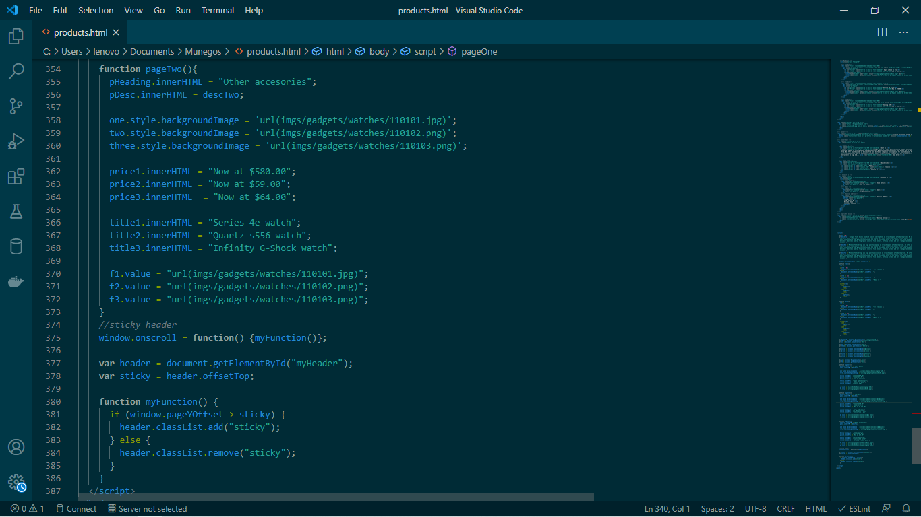

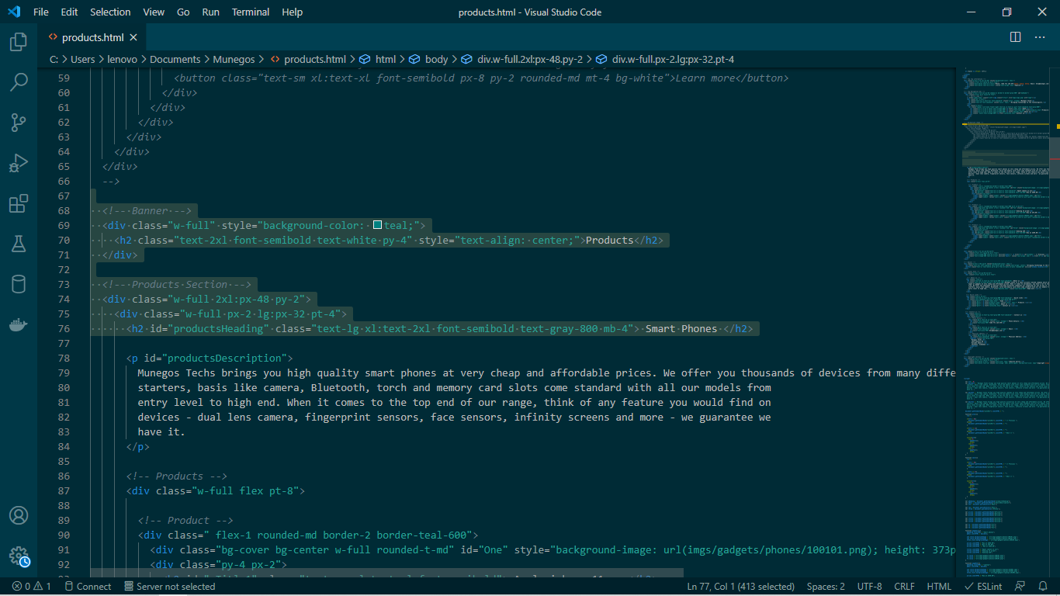

**Bugs**

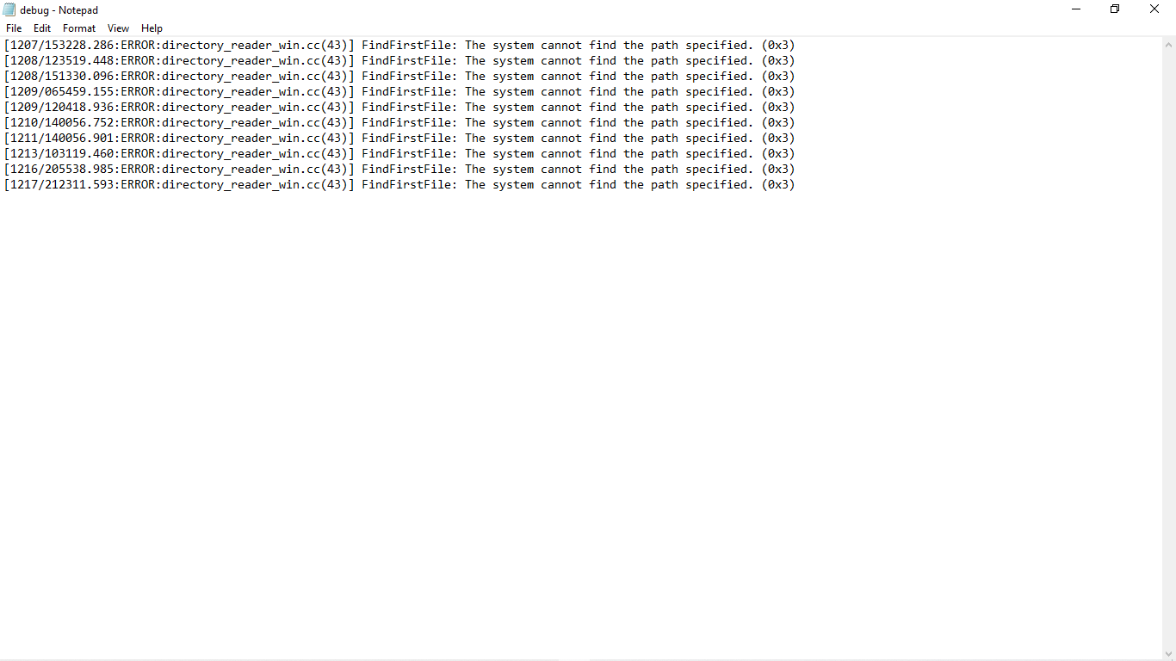

**Instructions on how to install the software**

* As long as one has any web browser on their PC they can open the software.

**How-to guides (Tutorials on how to use the software)**

Below is a video showing how one can use the system.

**Reference guides**

These are the technical references of our software’s code and basic description of the software.

**Testing**

The testing phase examines the performance of each existing function as well as additional functionality. In the testing phase, different methods are used to test the behaviour of each task.

* At the home page when the user clicks about us, it navigates to the about us page and it is as expected.

Home page

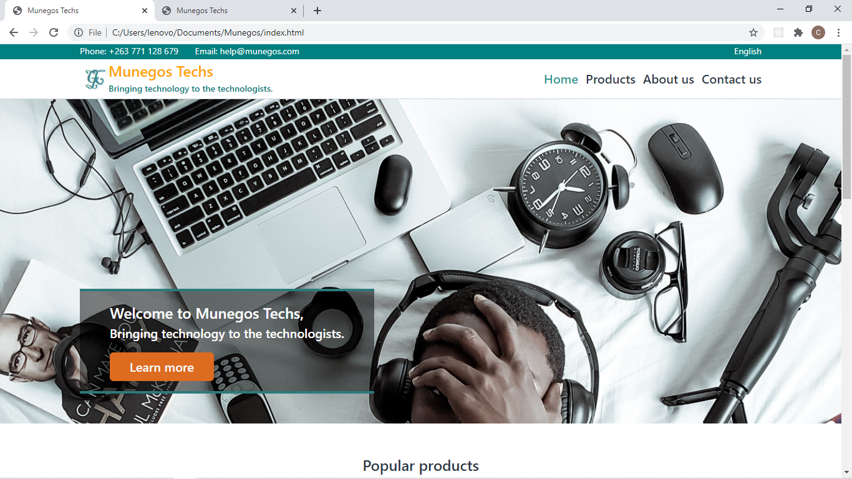

About us page

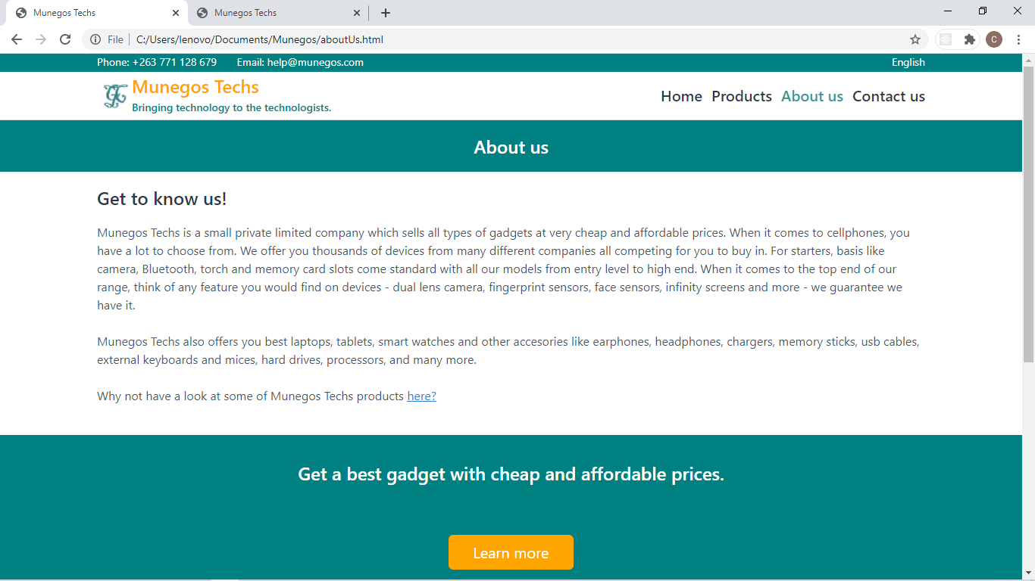

* At the home page when the user clicks contact us, it navigates to the contact us page and it is as expected.

Home page

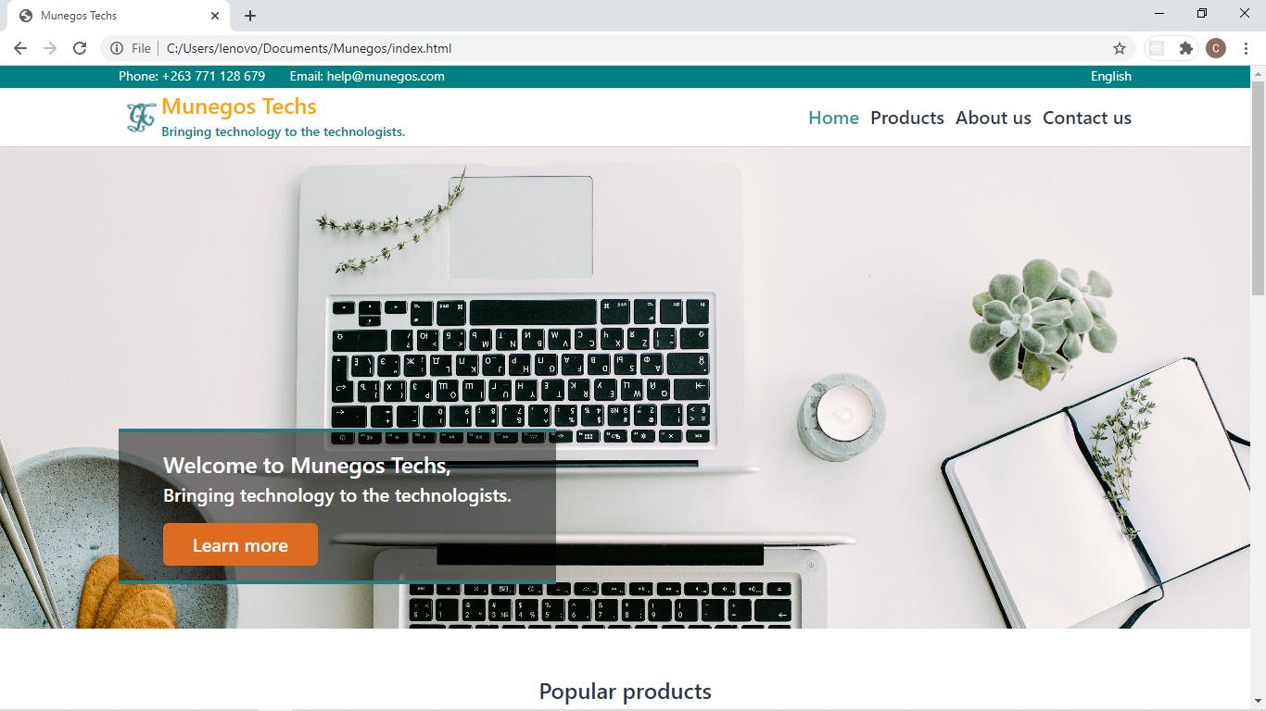

Contac us page

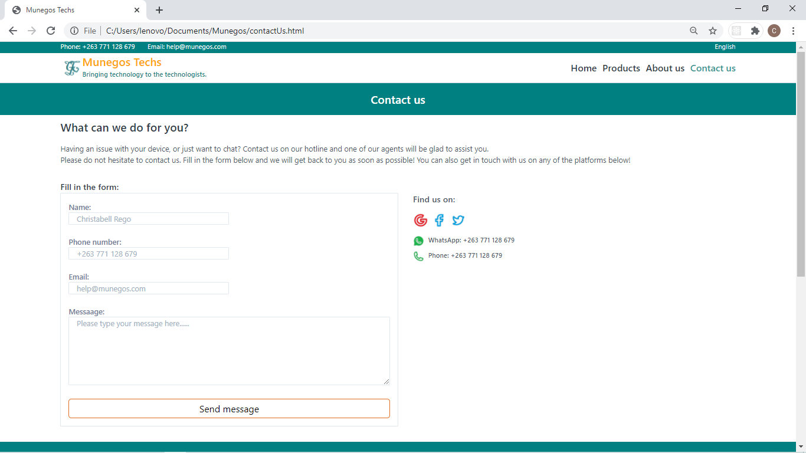

* At the products page when the user clicks the button on next on the bottom right side below the products, it navigates to the to the next products page, showing another category of gadgets and it is as expected.
* On the contact us page, one is not able to input phone number or massage, and it is **not** what the system should do.

After clicking the products link

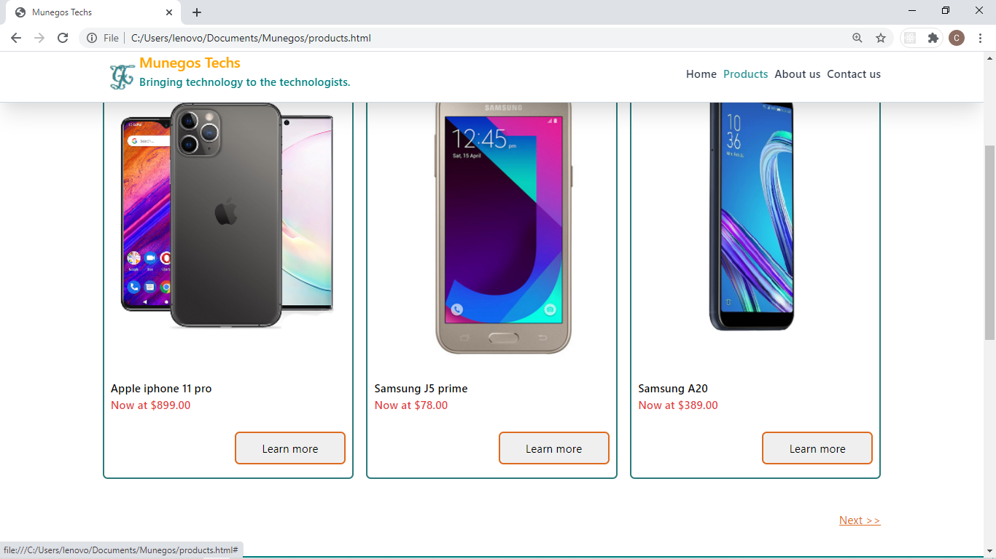

After clicking next on the bottom right corner on the product’s page.

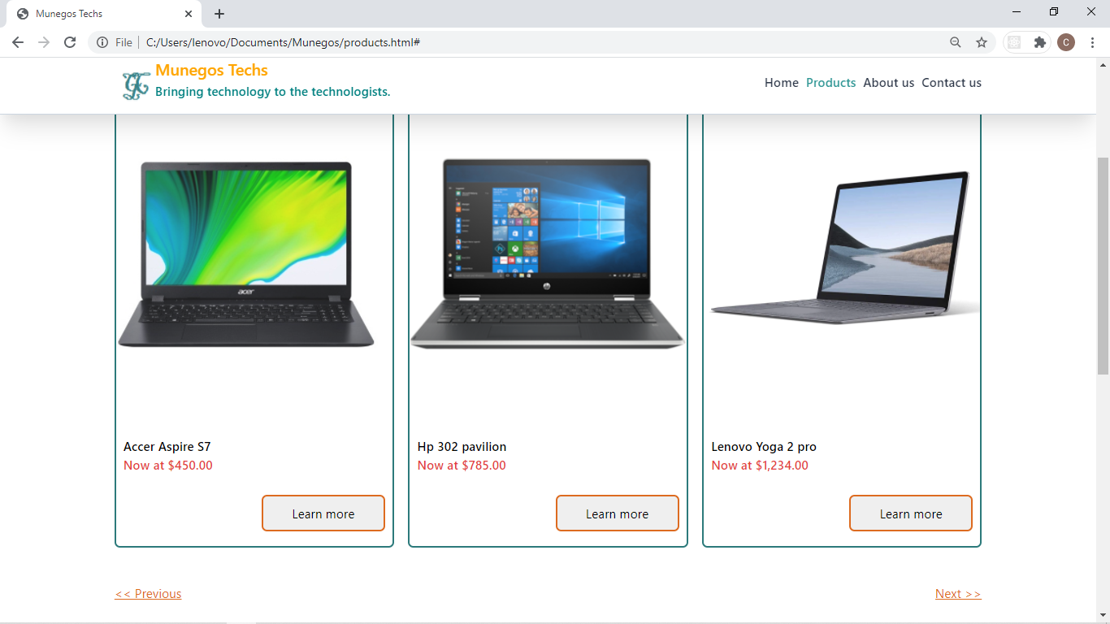

* At the products page when the user clicks the button on learn more on the bottom right side below each product or gadget, it provides a full detailed description of the product and the outcome is as expected.

Before clicking the learn more button on the Series 4e watch

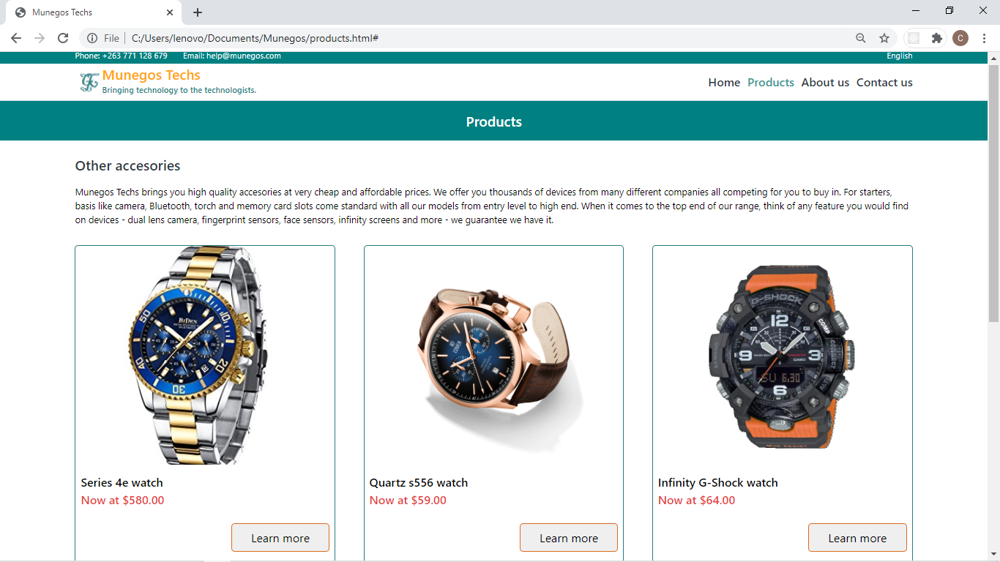

After clicking learn more button, the Series 4e watch. A detailed insight of the watch is provided i.e. details such as display, colour, chip, battery, weight and material are provided.

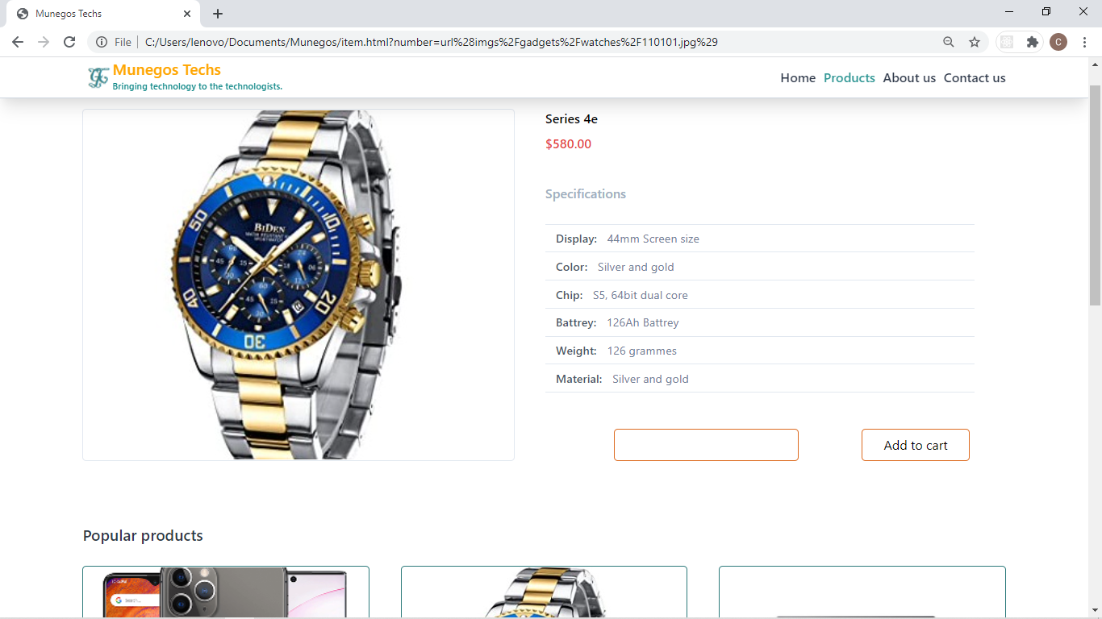

**Evaluation**

**Recommendation:** the system may be improved in the future by adding a chat box or chat section to the page where users can ask other users of gadgets recommendations etc.

**Conclusion**

Learnt how to develop a system, processes involved, system models and also learning object oriented analysis design so as to develop a quality system with a better life cycle. This project helped us sharpen our programming. Learnt how to develop the front end and back-end of websites using HTML, CSS, JS and PHP.

**References**

**Marking** **Grid**

|  |  |  |
| --- | --- | --- |
|  | **Marks Allocated** | **Marks Given** |
| Application and Navigational function | 15 |  |
| Web Forms | 12 |  |
| Connected Database | 8 |  |
| Developer’s Guide | 10 |  |
| Testing | 10 |  |
| Design Considerations | 5 |  |
| Accessibility | 10 |  |
| Initiative, Innovation and overall impression of Quality | 15 |  |
| Conclusions, Reflections and Recommendations | 15 |  |
| **Total Mark** | **100** |  |